Mechanical Engineering

Design Portfolio

**Ming Lin** (B.E. Mechanical Engineering ‘23)

**Ming Lin**

1050 Stonewall Lane, Secaucus NJ 07094 | 201-417-2039 | [minglianglin50@gmail.com](mailto:minglianglin50@gmail.com)

**OBJECTIVE**

Student at Stevens Institute of Technology 23’ pursuing a position in the field of mechanical engineering to explore careers in this field.

**EDUCATION**

**Stevens Institute of Technology**, **Hoboken, NJ** May 2023

**Bachelor of Engineering**: **Mechanical Engineering**

**GPA:** 3.4

**Awards:** NJIC Sportsmanship Scholarship, Edwin A Scholarship

**Course works:** Engineering Design I-II, Engineering Graphics, Intro to Programming, Mechanics, Biology and Biotechnology, Chemistry, Calculus I-II, Writing and Communication, Intro to Entrepreneurship, Engineering Experiences

**SKILLS**

3D Printing, SolidWorks, MATLAB, LabView, C++, Python, G-code, Microsoft Offices, CAD Design, Windows 10, Mac OS, CPR Certified, First Aid Certified, Fluent in Mandarin

**PROJECTS**

**3D Printing, Raspberry Pi, Arduino** Dec 2018 - Jan 2019

Creality Ender-3 3D Printer Modifications

* Utilized **3D printing** and **CAD** to 3D print parts and upgrade overall mechanical functionality.
* Used an **Arduino** Uno bootloader capabilities, to upgrade the firmware to open-source Marlin-based software to decrease the fire hazard as well as overall modularity.
* Used a **Raspberry Pi** 3B to improve Wi-Fi based capabilities, gaining the ability to control as well as monitor printer functions using a server-based GUI called Octoprint in real-time.

**SolidWorks and CAD Design** Sep 2018 - Dec 2018

Engine Block Design

* Modeled an 8-cylinder V configuration combustion engine block.
* Simulated the movement and functionality of the engine using **SolidWorks** rotary motor animation tool.
* Presented the design using the SolidWorks assembly and drawing tools.

**Engineering Design Term Projects** Sep 2018 - Dec 2018

* Used an Arduino Wemos Chips, Ultrasonic Sensors, DC Motors, and multiple machining tools to create an autonomous robot with the ability to dodge obstacles and navigate a course hitting 4 targets and returning to original position.

**EXPERIENCE**

Stevens Institute of Technology Jan 2019 - Current

**Research Assistant, Hoboken, NJ**

* Created a structured light 3D scanner that constructs 3D images from processing data that is taken from the camera and projector.
* Utilized **MATLAB** toolboxes such as **image processing** and **computer vision** to process data and calibrate the camera and project to detect real-world dimensions.

**US Citizen ­| Available May 2019**

**Engine Block**

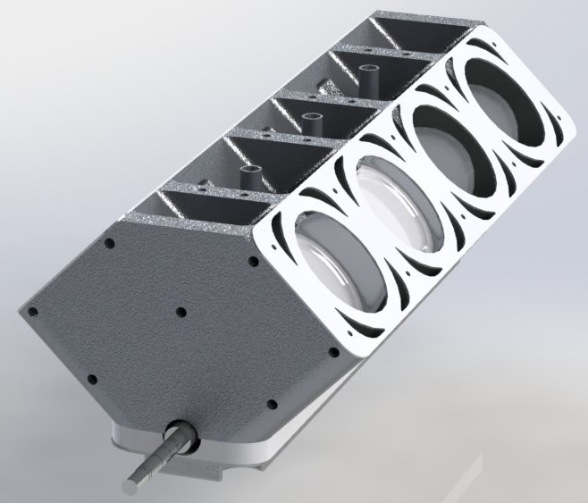**Project Title:** V6 Engine Block

Dimetric view of engine assembly

**Objective:** To design the main internal components of a V6 Engine with assembled parts and drawing. Used to create a motion study using the motor tool to simulate the function and motion of internal parts. This was a project for the Engineering Graphic Course (E120).

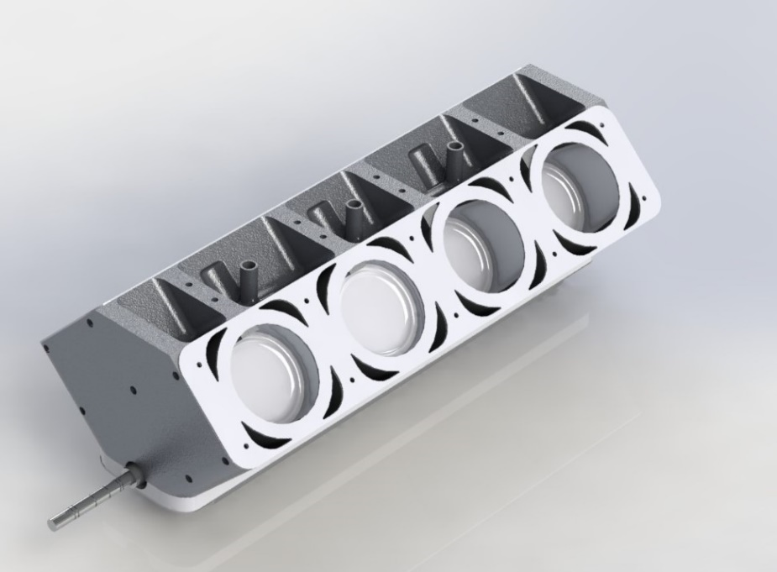

Isometric view of engine assembly

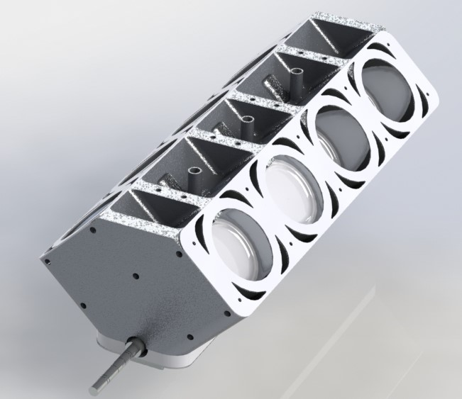

Trimetric view of engine assembly

**Engine Block: Few Engine Components**

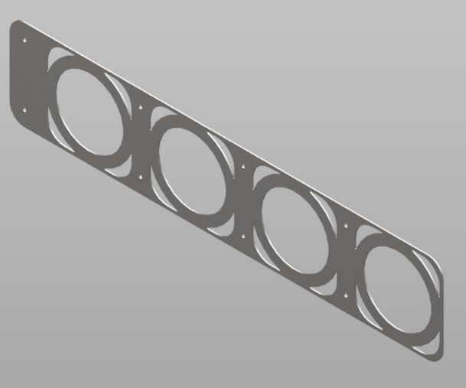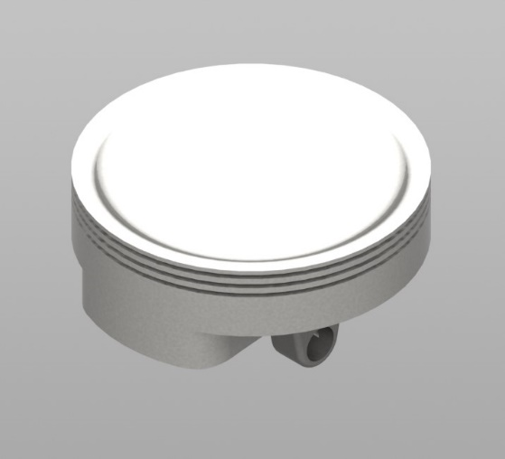

Piston Head

Gasket

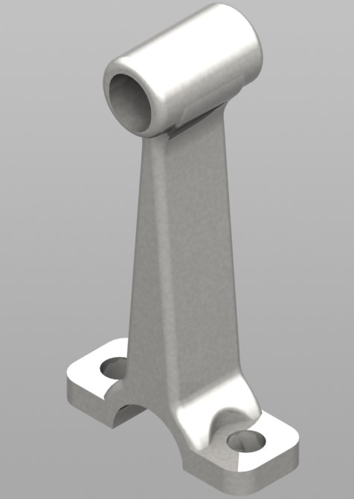

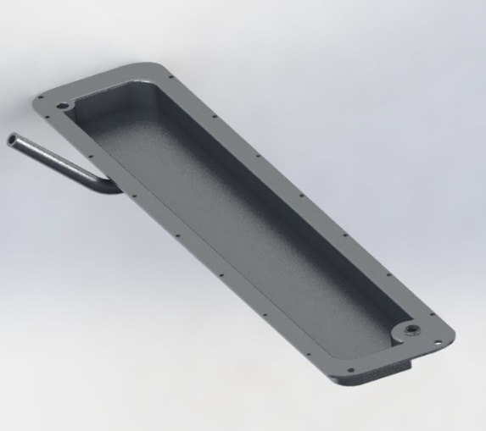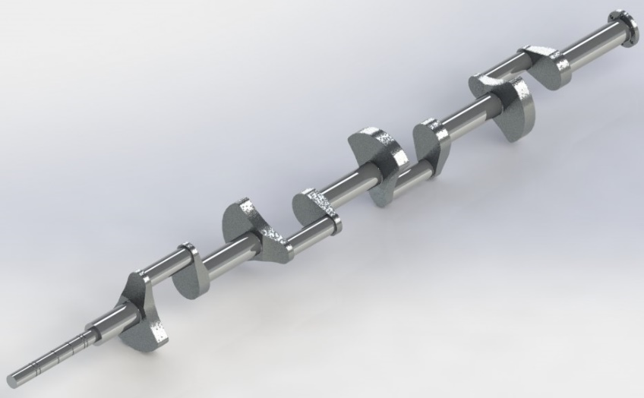

Connecting Piston Rod

Crankshaft

Oil Tray

**Engine Block: Assembly**

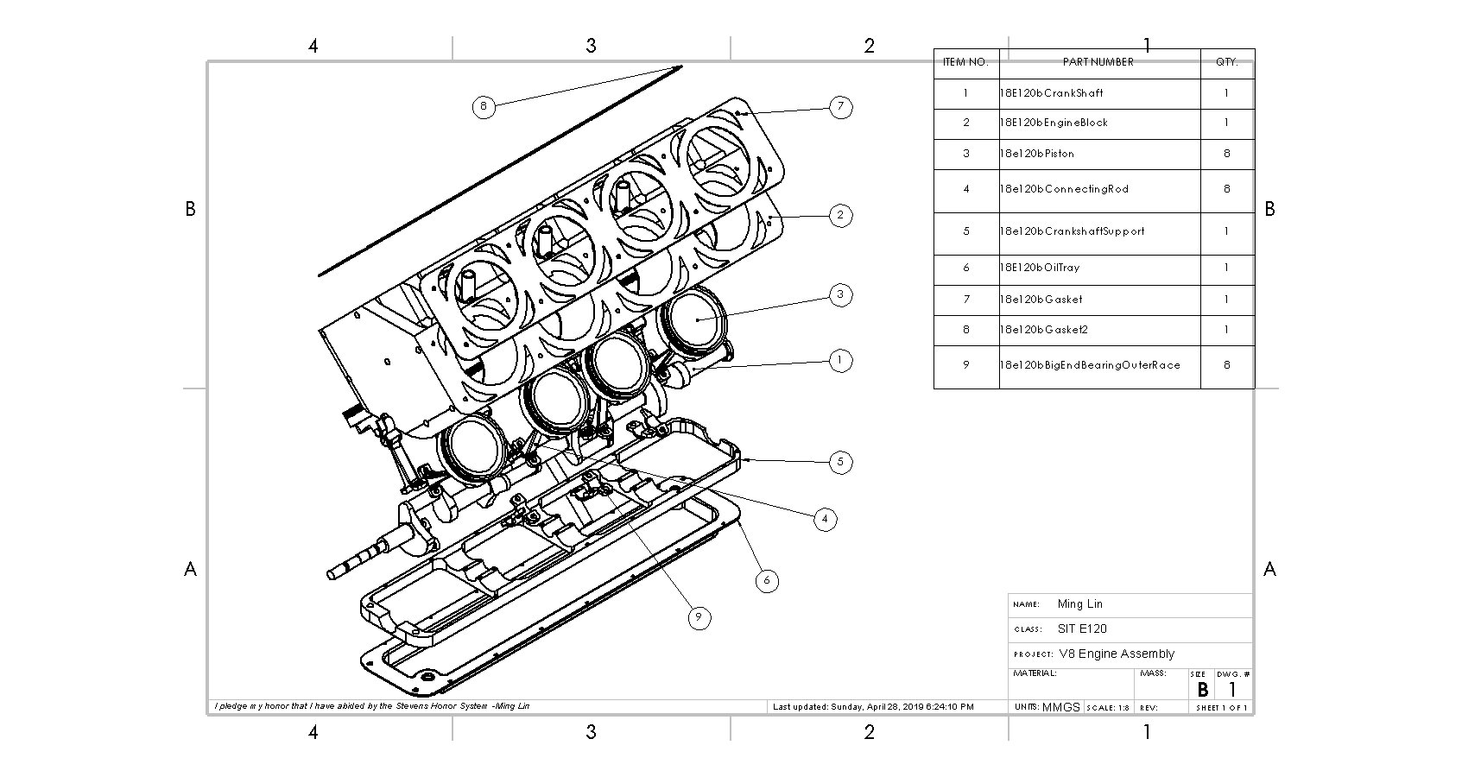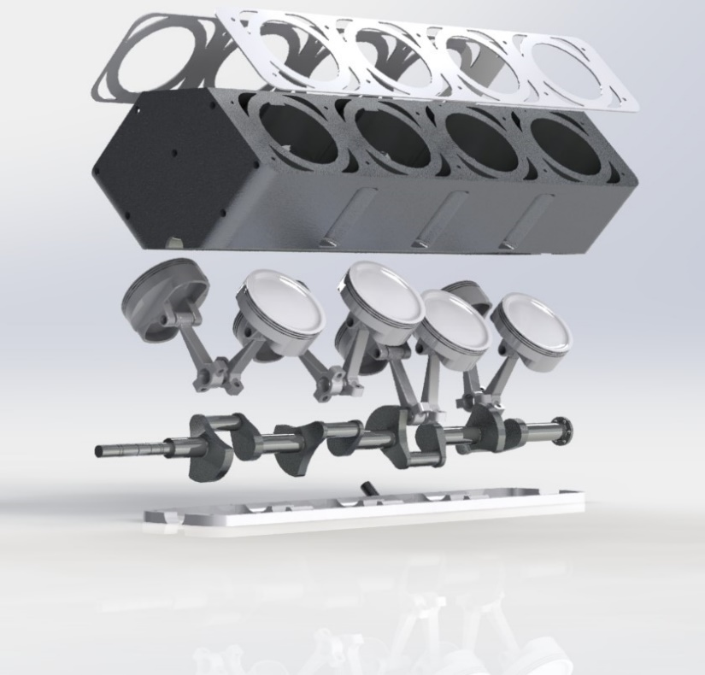

The image above is a drawing of an exploded view of the engine assembly with a bill of materials (BOM) in the drawing sheet modeled in Solidworks

The image above is an exploded view of the engine assembly

**Solar Car Cockpit**

**Project:** Solar Car Cockpit Panels

**Objective:** Create and model switches, indicators, panels, and gauge screens to be mounted to a frame of a solar car. Keeping in mind manufacturability and robustness. Simplicity is better.

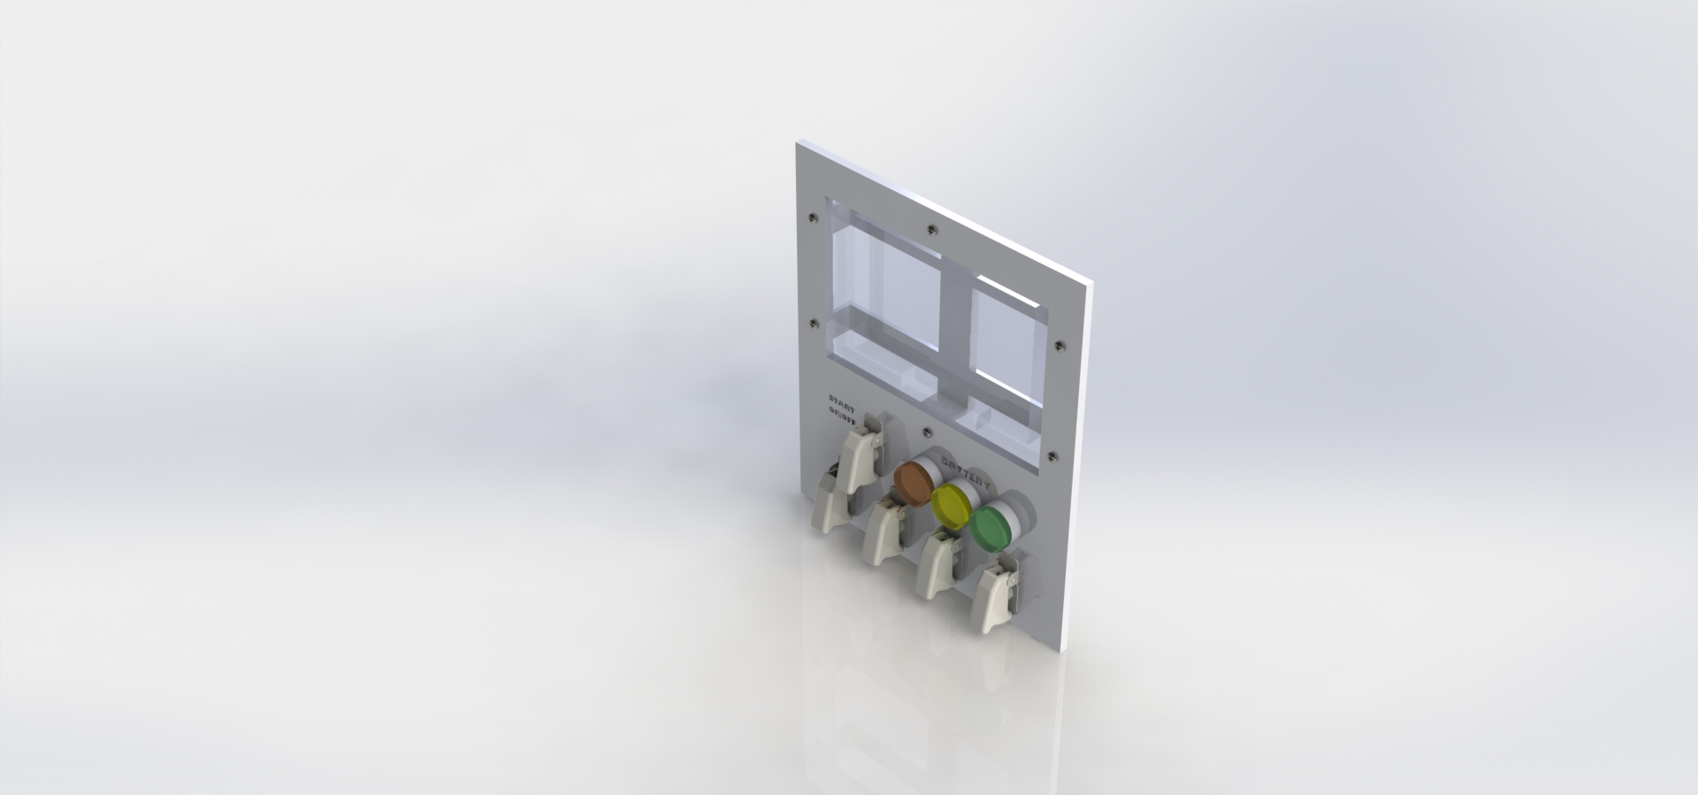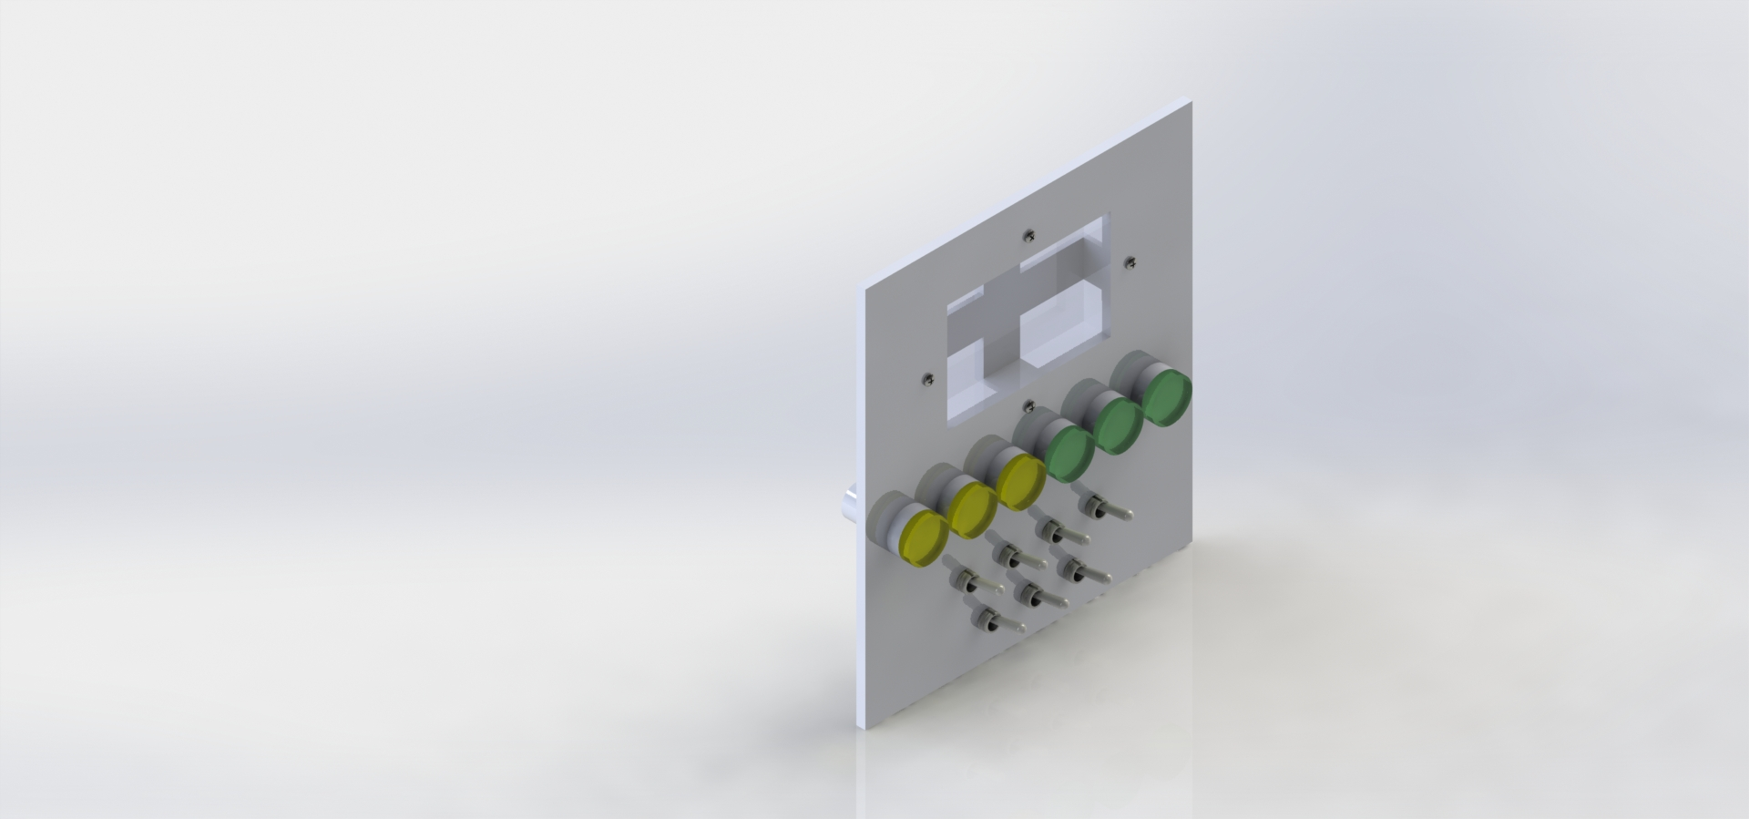

The image above is an isometric view of the right control panel assembly

The image above is an isometric view of the left control panel assembly

**Solar Car Cockpit: Left Control Panel Assembly**

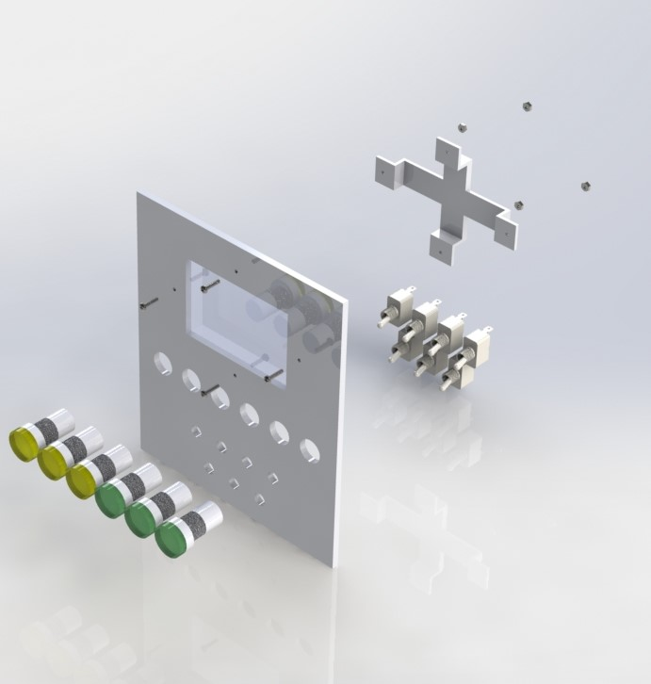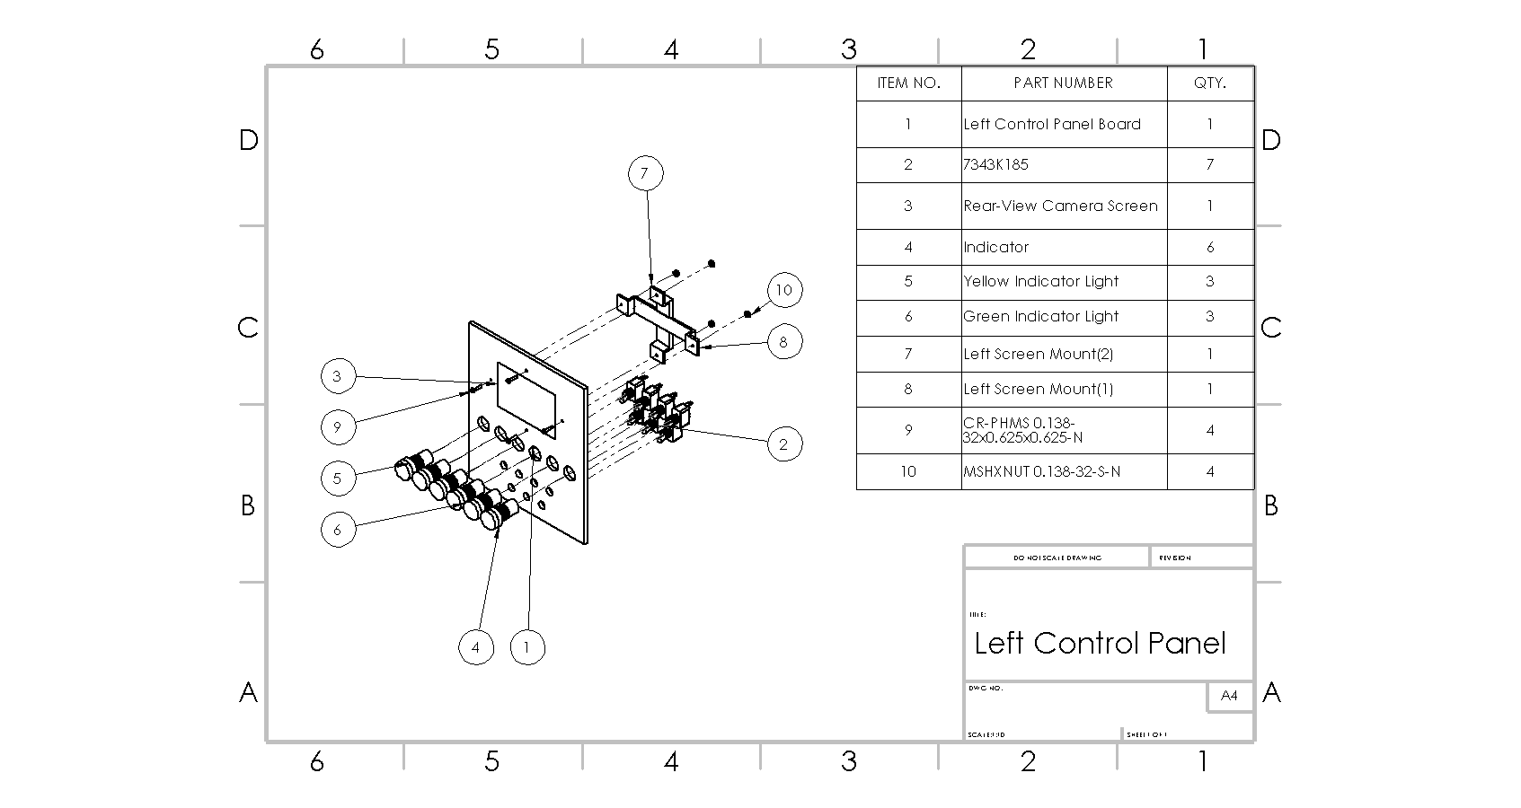

The image above is an exploded view of the right control panel assembly

The image above is a drawing of an exploded view of the left control panel assembly with a BOM in the drawing sheet modeled in Solidworks

**Solar Car Cockpit: Right Control Panel**

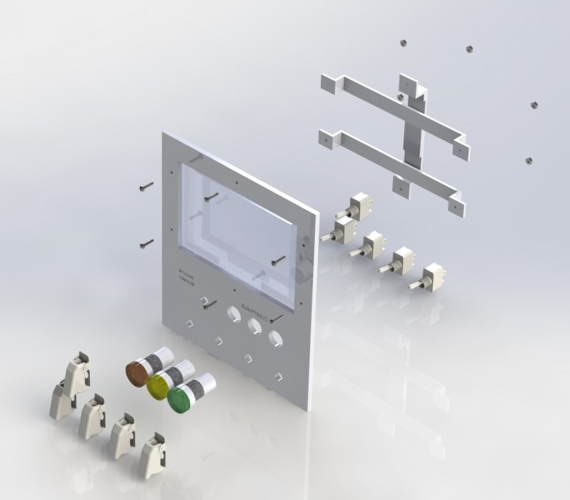

The image above is an exploded view of the right control panel assembly

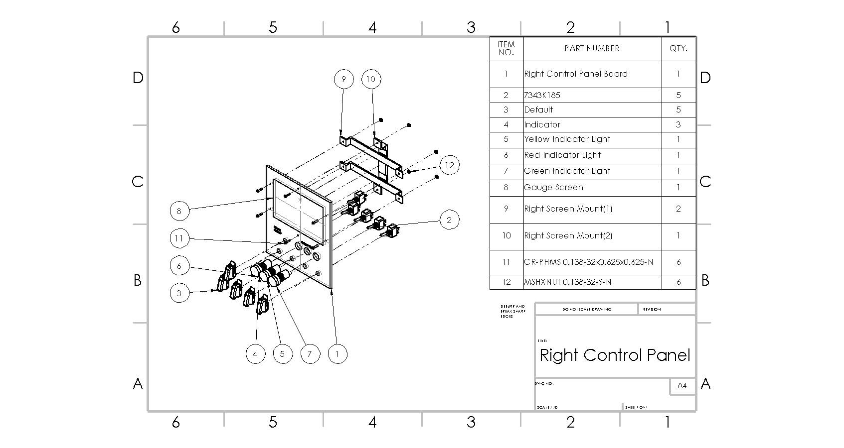

The image above is a drawing of an exploded view of the right control panel assembly with a BOM in the drawing sheet modeled in Solidworks

**Result:** Successfully designed two panels that the indicator and switches will be mounted on. The panels will be .25” aluminum sheets which will be CNC machined. The gauge screen will be mounted and supported by brackets that will be 3D printed and fastened with #6 bolts. The right panel holds the high-priority switches while the left holds the rest.

**Solar Car Cockpit**

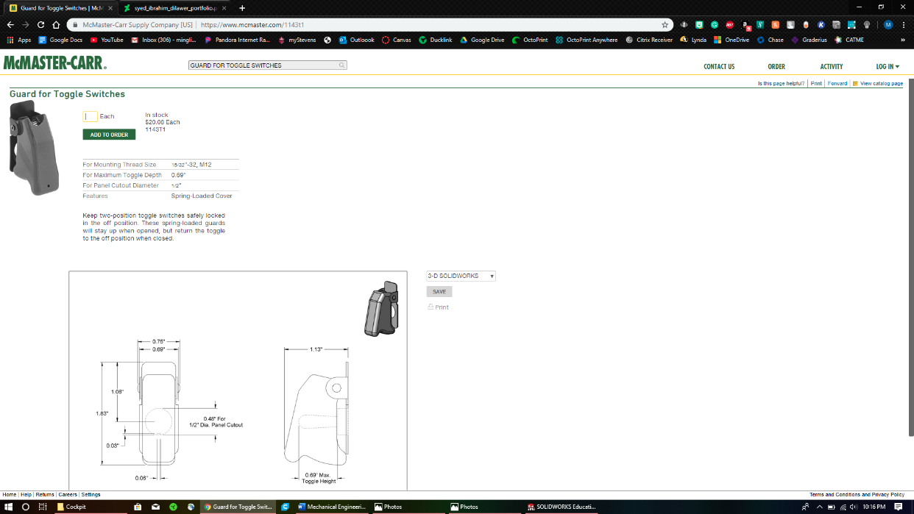**References** Used model for toggle switches and cover from the website below as references to model around

<https://www.mcmaster.com/1143t1>

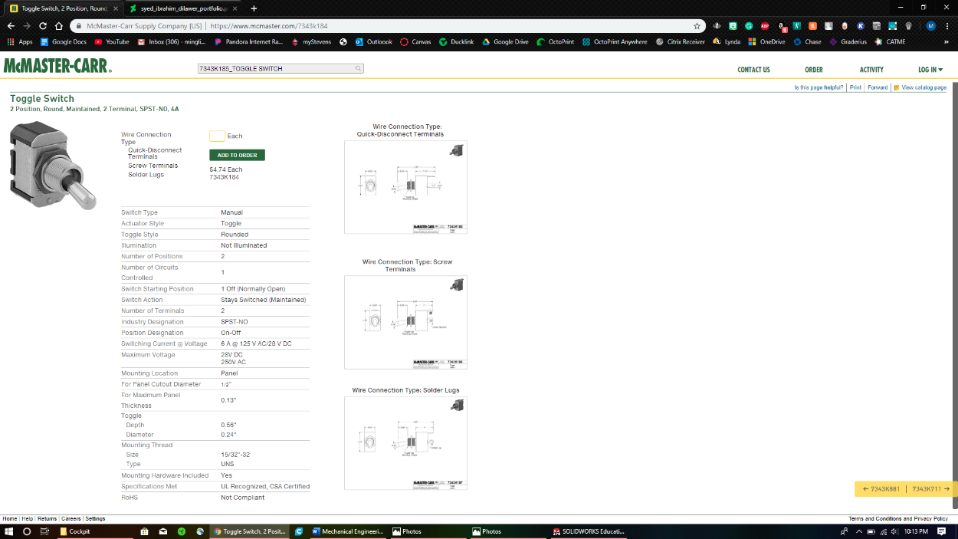

<https://www.mcmaster.com/7343k184>